<a href="/role-delete?id=${line.id}" class="btn btn-sm btn-danger">Xóa</a>

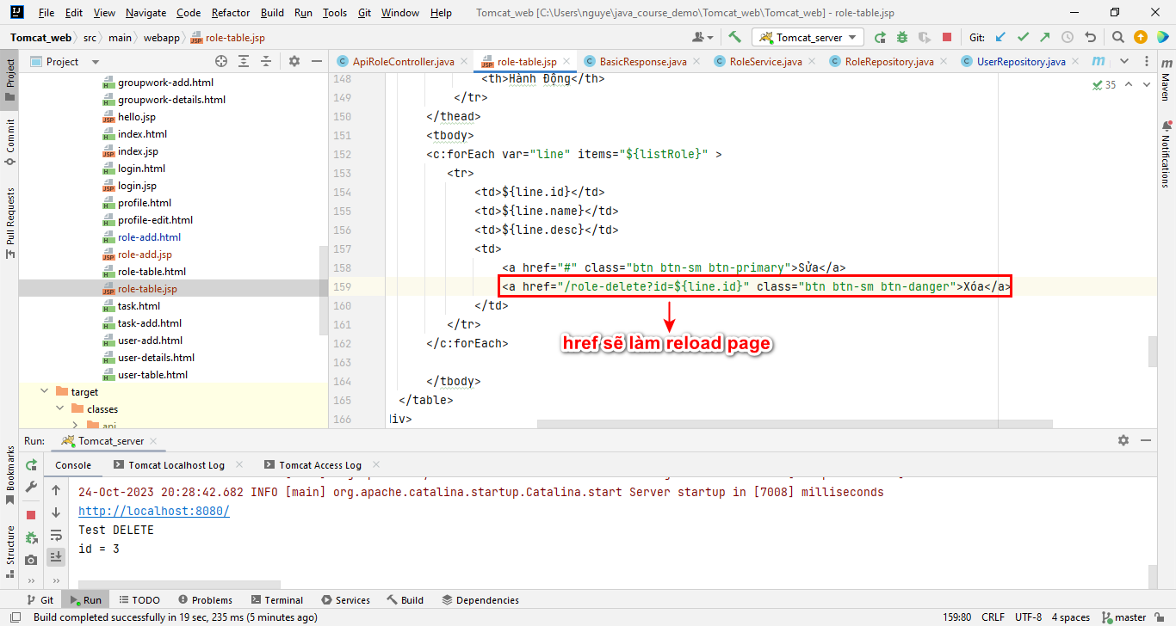

<script src="plugins/bower_components/jquery/dist/jquery.min.js"></script>